Motivator Scores: Norms, Intensities, and Risks

Understanding what motivates us, what inspires us, and is deemed
important by us is a vital first step in self-awareness and improving
human performance and effectiveness. Knowing our specific
level of motivation can be crucial to helping us understand what drives
our beliefs and actions so we can bring them into alignment.

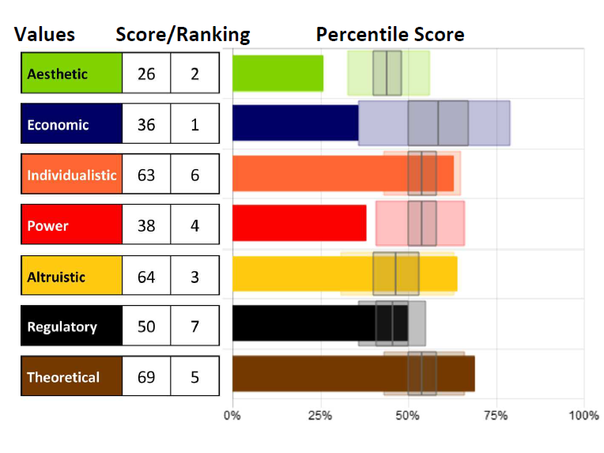

Norms – Grey Shaded Box Plot & Color Shaded Boxes
- The norm score represents the mean score: the average score is the line through the center of the grey box plot.
- The color shaded box shows the general population scores for each motivator - 50% of the population falls within the shaded box.
- The grey box plot shows the majority of those scoring from the general population scores for each motivator (50% of the population falls within the shaded box, and 50% of that 50% is noted with the grey box plot).
- Both low and high scores can have an influence on the choices we make. Average scores (in the mid-range shown as the grey box plot) create a normal degree of influence which is typically not noticeable.

Intensities
- Scores that fall within Average will have less impact because they are without passion; scores that are higher or lower have more passion for or away from the motivator. Those in the middle could go either way, depending on the situation and are considered balanced.
- Whether scores are high or low, the motivators with the furthest distance above or below 50% will be the most influential, leading to the greatest impact on decisions. This is shown as the RANKING.
Example above: The highest individual influencers in order will be Economic, Aesthetic, Altruistic, Power, Theoretical, Individualistic, and Regulatory (see ranking scores 1-7)
*Note: The low Economic and High Altruistic lines support one another in this example; they create a stronger relationship in giving to others at the expense of self. This will make them more powerful because they are supporting the same qualities.

Risks
- The very high and very low scores are "red zones" or risk zones. These are areas outside of what most of the population will understand and are considered extreme or over/under extended. If you score in a risk area, that means you have a strong need in that area that will drive more of your decisions and actions.
Example:
If you are high AES, you have a strong need, much more than a want, to be alternative and to create balance and harmony in your world.
If you are low AES, you have a strong need, much more than a want, to be practical and real-world results focused.

There is a difference - I can WANT to be a leader or I can NEED to be a leader; each will affect my choices and behaviors.

- What do you notice in your scores?
- What is within the average, or high or low for you?
- What, if any, are risks you may want to explore?

Assessments 24x7 LLC 5927 Balfour Court, Ste. 103 Carlsbad, California 92008 USA (206) 400-6647

